Your path to Confirmation, and beyond…..

On Tuesday 12th March you will be confirmed by the Bishop of Liverpool, the Rt Revd Paul Bayes

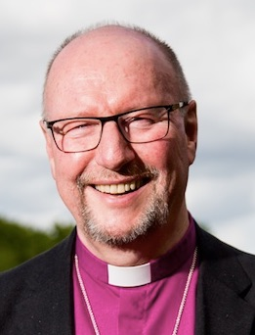

Bishop Paul has asked that you write to him to tell him

(a) Something about yourself,

(b) Something about your faith journey,

(c) Something about why you are choosing to be Confirmed.

Please would you kindly fill in the boxes below (and use additional sheets if you like) and return the completed form to Bishop Paul at least 2weeks in advance of your Confirmation either by e-mail: [bishopslodge@liverpool.anglican.org](mailto:bishophertfordpa@stalbans.anglican.org)

or post: Bishop’s Lodge, Woolton Park, Liverpool L25 6DT

*My name is*

*My spiritual journey*

*I have decided to be Confirmed because*